**Exp 2**

Circuit Diagram

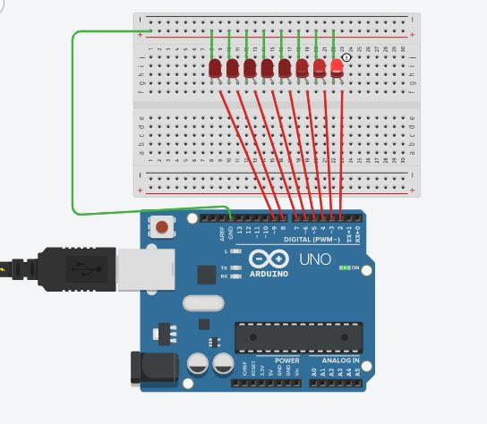

Theory

Concepts Used

The concepts used in the current project are listed as:

1. Parallel circuit
2. Basic insights of the Arduino Uno’s digital input/output pins
3. Algorithm to obtain the effects of chaser lights
4. The usage of circuit prototyping board or bread-board

Learnings and Observations

The following events where observed as the experiments approaches to completion:

1. Modify the code always give something else but the desired effect and may even give an error.

Precautions

These points need to be kept in mind while making the circuit:

1. Always ensure the positive terminals of the LEDs is connected to the output pin of the Arduino Board.
2. Before uploading the code to the microcontroller check the port and board under the tools menu.

Learning Outcomes

The learnings from this experiment are illustrated as follows:

1. Understanding the in and outs of working of a bread-board
2. Increased understanding of the code used in Arduino IDE.